21. Install Virtualbox/VMware Workstation with different flavours of linux or windows
OS on top of windows 7 or 8.
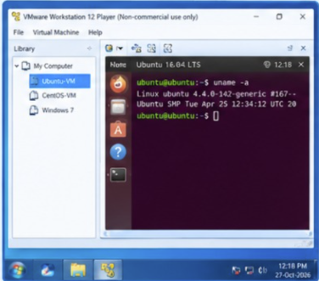
22. To write a procedure to run the virtual machine of different configuration and to check
how many virtual machines can be utilized at a particular time.
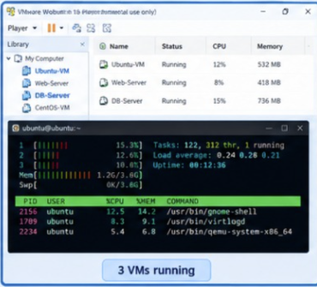
23. Write a Procedure To Attach Virtual Block To The Virtual Machine And Check
Whether It Holds the Data Even After The Release Of The Virtual Machine
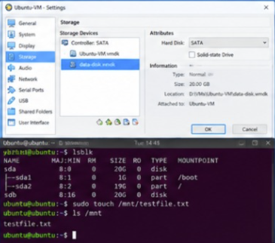
24. To showcase the virtual machine migration based on the certain condition from one
host to the other.
